MAKATON SIGNS | Week 1 | Week 2 | Week 3 | Week 4 | Week 5 | Week 6
 | Good morning  Good afternoon  Please  Thank you  Sorry | Help  More  Yes  No  Toilet | Sit  Walk  Jump  Up  Down | Sad  Happy  Angry  Stressed  Excited | Poorly  Hungry  Thirsty  Tired  Cold | Wait  Stop  Danger  Go  Look
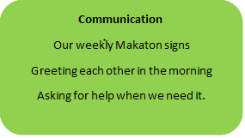
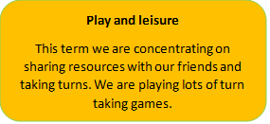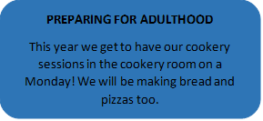

Communication
Play and leisure

This term we are concentrating on sharing resources with our friends and taking turns. We are playing lots of turn taking games.
PREPARING FOR ADULTHOOD
To know about the range of things that help make and keep them healthy.
I can take turns and share with others
I can ask for help

1EP & 1LW
Out and about in the community
Understanding the changes in the seasons
HEALTHY BODY AND MIND
Healthy eating
Food and exercise

Problem solving

I can explore cause and effect using Bee-Bots.
Following a simple set of instructions for our instructions.
Creativity
Digital photography
Autumn pattern making
Shape and pattern pictures

Independence

Preparing myself for meals.
Putting all my belongings in the right place each morning.
Stories we are sharing
Three little pigs
The very busy spider
Goodnight, goodnight construction site
The Enormous crocodile
Charlie and the chocolate factory

TERM THEME
Master Builders

