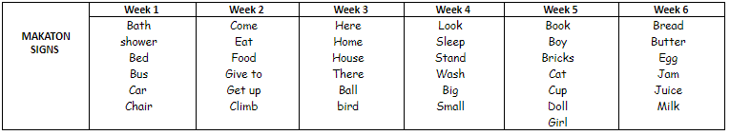

Communication

Preparing for Adulthood

This term we are focusing on making simple hot snacks safely. We will be cooking eggs in different ways, bacon and sausages. We will also be making toasted sandwiches.

Functional English

During Functional English we are focusing on skills that will help us into adulthood. We will again be using google search by voice (or google search where relevant) to find key information about places we are visiting, practising our personal information, and reading for purpose.

Keeping Safe

We are completing Unit 1- Know how to stay safe when out and about, and Unit 2- Know how to travel safely on different types of public transport of the ‘Getting about Safely’ Award.

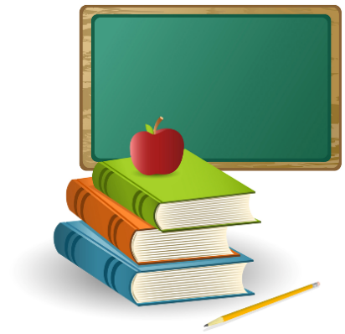

Spring 2

Creativity

(With Miss Emily)

During creativity we will be doing a printing project, focusing on Andy Warhol and learning new techniques along the way.

Functional Maths

Functional maths this term is through real life situations and is focusing on number, shape, data Handling and money.

World of work

During this term we will be visiting different retail environments and interacting with the shop staff. We are planning on visiting the Range, Wickes, Go Outdoors and Dunelm. We will also be visiting Lincoln station and the Collection Museum

Enterprise, Social, Moral, Spiritual, Cultural

This term we will be focusing on Shrove Tuesday, Mother’s Day, Holi , World Water Day and Easter!

**4SN**