 **Independence – cooking, dressing and undressing**

We will be working on this on Wednesdays when the students will be getting changed into their PE kits and back, also in our daily personal care work and in preparation for going outside. Cooking is a daily option at breakfast time and also an afternoon activity. This term we will be making fruit salads.

**English – rhyming words**

The students will be using our class text for the term to either predict the words to fill a gap, choosing a word that rhymes with a given word, or matching images from the pictures in the book.

Communication

**Keeping safe - puberty**

We will be starting to learn about the changes to our bodies during puberty, supported by ‘the Sex factor’ stories of ‘Dalip’s deodorant’, ‘Haider’s growing hair’, and ‘Pippa’s period’.

jguili

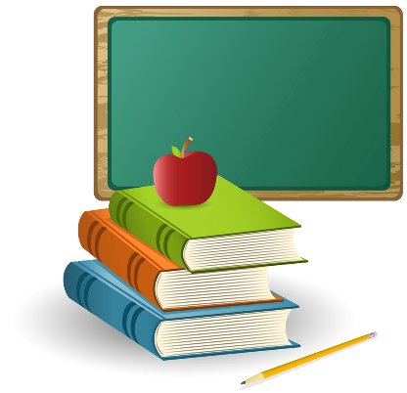

**Healthy body & mind – People, weather and seasons**

We will be spending some time thinking about activities we can do with familiar people, what ‘superheroes’ we know, and spending time outdoors as often as possible.

**Stories we are sharing**

Linking to our ‘rhyming words’ themes from English as well as the overall theme of ‘monsters, dragons and superheroes’, our book for the term will be ‘Superworm’.

**The World about me – recycling & weather and seasons**

We will be looking to to ‘re-purpose’ some old clothes, make tie-dye t-shirts, take some old clothes to a charity clothing bank and find out what happens to clothes when we recycle them.

**Maths – Number recognition**

We will be doing some work on counting small groups of objects and recognising ways of visually representing numbers, eg. Numerals, dot patterns, etc.

**Creativity – Outdoors**

In line with our Superworm book we will be sowing seeds and creating a wildlife friendly garden.

**2GT – Informal pathway**

**TERM THEME**

**Monsters, dragons and superheroes**